**Awaiting Ticket Resolution.Initiate ATT PPRQ**

Condition:

Confirm with user if PPRQ’s Built , TN’s ported/TTU Completed for the order.

Example: 157512824

***Step 1*** : Check if the task Awaiting Ticket Resolution.Initiate ATT PPRQ is in Ready State using the below query:

**Inconcert SqL Query:** -

Select ord.purge_IND,ms.ms_task_id,ord.usrp_order_number,sub.order_gate1_status, sub.ms_sub_order_id,sub.wan_link_ip_addr, wf.name, wf.status, wf.job_id, wf.task_id, wf.first_ready_time,wf.ready_time, wf.due_date, wf.done_time, wf.first_ready_time,wf.skipped_time, wf.perform_condition, wf.ITERATE_CONDITION

from ms_order ord, ms_sub_order sub,ms_job j,wf_task wf,wf_job job,ms_task ms

where

Ord.Usrp_Order_Number In

('157512824')and ord.ms_order_id = sub.ms_order_id and ms_sub_order_id = j.entity_id

and wf.job_id= hextoraw(j.wf_job_id) And Wf.Job_Id = Job.Job_Id and wf.task_id= ms.WF_TASK_ID

and j.entity_type=5 and (wf.status in (1));

**mS Updates SQL Query:-**

SELECT usrp_order_number, o.ms_order_id, ms_sub_order_id, t.name, t.status_updated_date , t.status, t.* FROM ms_task t, ms_job j, ms_order o , ms_sub_order so WHERE usrp_order_number IN ( '194943727' ) AND so.ms_order_id = o.ms_order_id AND entity_id = ms_sub_order_id AND entity_type = 5 AND t.wf_job_id = j.wf_job_id and t.status = 1;



**EFMS GUI** [**URL :-**](URL:-)

[**http://efmsms.it.att.com:8008/MS**](http://efmsms.it.att.com:8008/MS)

**EFMS GUI:**

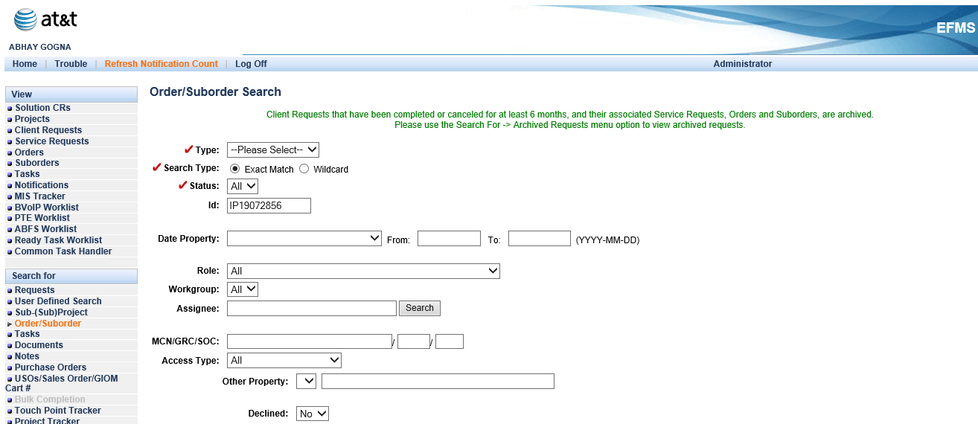

**Order / Sub-Order Level:**

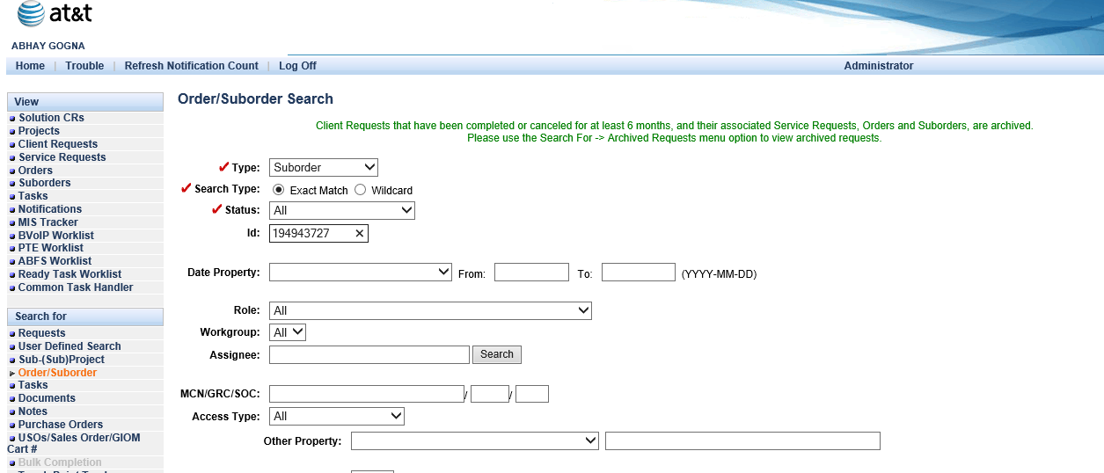

**Task List:**

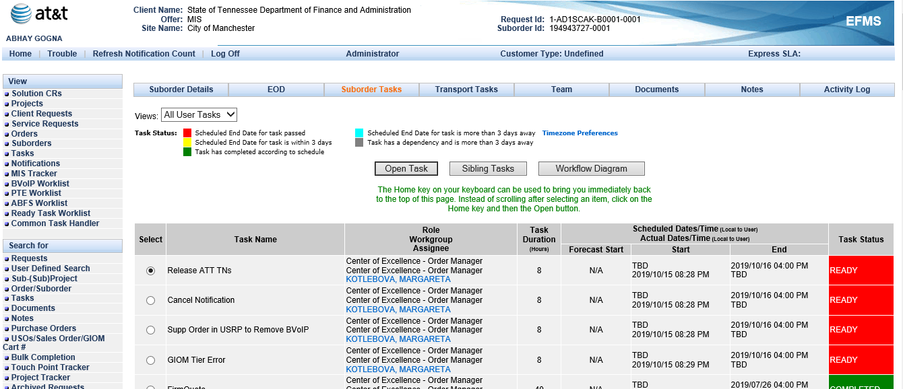

***Step 2***: Use the below query to get the task id for Porting Parent:

Select ord.IP_CENTREX_IND,ord.usrp_order_number,sub.SUB_ORDER_SEQUENCE, sub.ms_sub_order_id, wf.name, wf.status, wf.job_id, wf.task_id, wf.first_ready_time,wf.ready_time, wf.due_date, wf.done_time, wf.first_ready_time,wf.skipped_time, wf.perform_condition, wf.ITERATE_CONDITION

from ms_order ord, ms_sub_order sub,ms_job j,wf_task wf,wf_job job

where Ord.Usrp_Order_Number In('157512824')

and ord.ms_order_id = sub.ms_order_id and ms_sub_order_id = j.entity_id and wf.job_id = hextoraw(j.wf_job_id) And Wf.Job_Id = Job.Job_Id and j.entity_type=5 and (wf.status in (5) and wf.name like 'Porting Parent%');



**Workaround:** Segment skip the porting parent (4th Parent) of Awaiting Ticket Resolution.Initiate ATT PPRQ

**Steps to Segment Skip the task_id:**

**Step 1**: Login to asprd246.aldc.att.com machine



**Step 2:** Go to misprj/segskip directory



**Step 3:** Use segskip.ksh task_id( Note:Put the Porting Parent Task Id to Skip)



**Step 4:** Hit **ENTER**